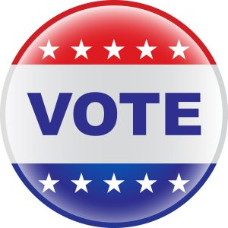
Election Day – Tuesday, November 3, 2026
The Candidates
Governor of Michigan
Jocelyn Benson (D) Jocelyn Benson for Governor
John James (R) John James for Michigan
United States Senator
Abdul El-Sayed (D) Abdul El-Sayed – Michigan U.S. Senate Candidate 2026
Mike Rogers (R) Mike Rogers for Senate
State Representative in US Congress – Michigan’s 3rd District
Terri DeBoer (R) Terri DeBoer | Join the Movement Today
Representative Hillary Scholten (Incumbent) (D) Representative Hillary Scholten |
State Representative – Michigan’s 88th District
Kiel Reid (D) Kiel Reid for State Representative - House District 88
Representative Greg VanWoerkom (Incumbent) (R) Greg VanWoerkom for State Representative | About Greg VanWoerkom | Michigan House Republicans
State Representative – Michigan’s 89th District
Joe Moss (R) Joe Moss for State Representative - Michigan House District 89
Meegan Zickus (D) Meegan Zickus
State Senate – Michigan’s 31st District
Chris Kleinjans (D) Real Leadership. Real Service. Real Results. - Chris Kleinjans for Michigan Senate District 31
John Wetzel (R) Elect John Wetzel | Michigan State Senate
*Updated 8.18.26

