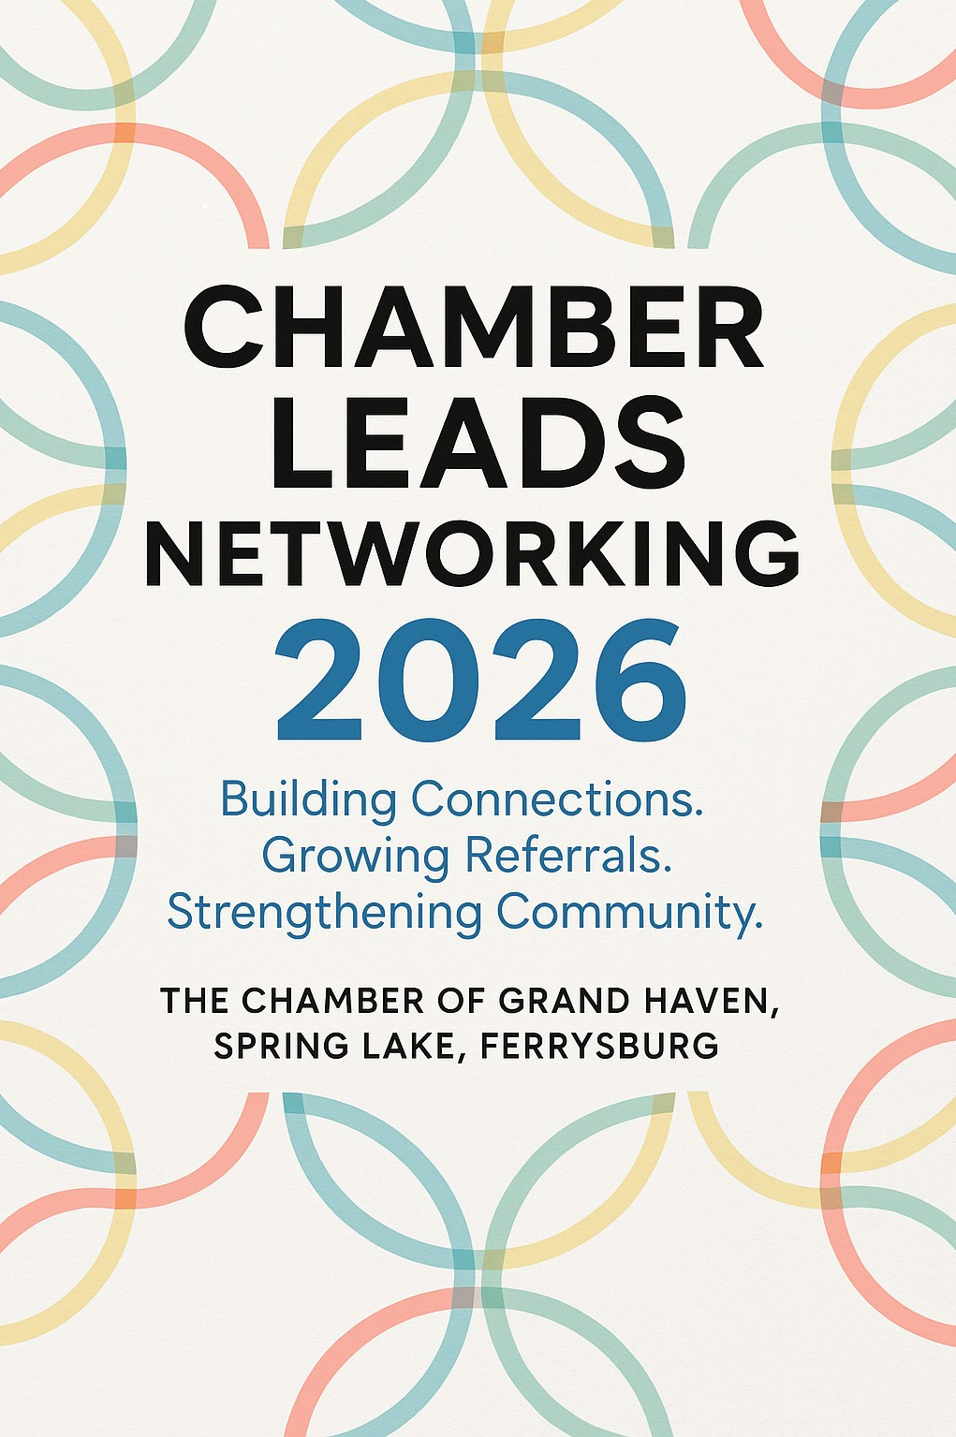

LEADS
Leads • Educate • Advocate • Develop • Support
Connecting Professionals. Cultivating Growth. Empowering Success.

Table of Contents

Pages 3-4 Weekly Agenda
Pages 5-6 Guidelines and General Policies
Pages 7-8 Attendance Policy
Page 9 Expectations of Membership
Page 10 Leadership Positions
Pages 11-12 10-Minute Presentations
Page 13 10-Minute Presentation Template
Pages 14-15 Anatomy of a 60-Second Commercial
Page 16 One on Ones
Page 17 Networking Don’ts
Page 18 LEADS Categories
Page 19 Motivation and Friendship in Networking
Page 20 Contact Information

Weekly Agenda - LEADS Networking

Welcome
- Introduction of guests and officers:
  - Chair
  - Vice Chair
  - Secretary
  - General Member
  - Networking Educator
  - Sergeant of Arms

Our Purpose
We are here to build a trust circle of professionals from diverse industries. Together, we create a network of relationships, referrals, and testimonials that help each other grow. By being here today, you’ve made a commitment to support your fellow members and strengthen our business community.
Attendance
- Who’s missing today?

Approval of Minutes
- Review and approve last week’s minutes.

10-Minute Presentation & Questions
- Spotlight on today’s presenter.
- “Now that we know more about what _____ does, let’s do our best to offer _____ more leads in the future and keep in mind what areas of business their asks fall into.”
- Next week’s speaker will be: __________

60-Second Commercials
- Each member stands to share their commercial.
- Format: “A good lead for me today is…”
- After each, the Chair will invite questions.

Board Reports
- Chair’s Report
- Vice Chair’s Report
- Secretary’s Report
- General Member’s Report
- Networking Educator’s Report
- Sergeant of Arms Report

Information & Updates
- Announcements (business/community events, Chamber news, etc.)

Referrals, Testimonials & Leads Moments
- All members are expected to bring at least one of the following each week:
  - A lead
  - A networking moment
  - A potential member
  - A guest of special interest
- Number of leads passed today: __________

Closing Remarks & Adjourn
- Wrap-up thoughts from the Chair.
- “Have a great week!”

Chamber LEADS Networking Groups

Guidelines & General Policies – 2026

Membership
- Members must be current Chamber members in good standing and pay a non-refundable $150 annual fee to participate.
- Each member exclusively represents their business category within the group.
- Members may only participate in one Chamber LEADS Networking Group, but may fill-in as a sub if a request is sent to Hanna Crouch.
- Weekly meetings are required and may last up to 90 minutes.
- Participation is measured by:
  - Passing leads
  - Bringing guests
  - Giving testimonials
  - Attendance
- Groups are designed to be ongoing. Seats are held as long as the member is active, maintains Chamber membership, and chooses to stay.
- Seats are filled on a first-come, first-served basis as applications are received.
- Membership may be revoked for unethical business practices, upon recommendation from group leaders to the Chamber staff liaison.
- If a participant changes employers:
  - They may retain their seat if they personally paid for their membership and the new employer is a Chamber member.
  - If the company paid, the company may fill the seat with a new representative, pending group approval and interview within two weeks.
- LEADS Networking Groups will not promote any policy that conflicts with Chamber policies and procedures.
Member Selection Process
- Potential members may visit a group twice before deciding to join.
- Upon receiving a completed application:
  - The Vice Chair will contact the applicant to schedule an interview.
  - After the interview, the applicant will skip one meeting to allow the group time to consider.
- Applicants will be notified of their status within one week of review.
- If there’s a classification overlap, applications will be held in order of submission for future openings.

Leadership Positions
Leadership terms run January-June and July-December. Each group includes:
- Chair
- Vice Chair
- Secretary
- Networking Educator
- General Member
- Sergeant at Arms

Chamber LEADS Networking
Attendance Policy - 2026
The Chamber of Grand Haven, Spring Lake, Ferrysburg

Quick Reference
Action | Result
3 Unexcused absences within 6 months | Warning
4 Unexcused absences within 6 months | Classification subject to review
3 times tardy or leaving early | Counts as 1 absence (Tardy=15+ min late)

Attendance Expectations
- Weekly meetings last up to 90 minutes.
- Attendance is required. If you expect to be absent, notify the Secretary in advance - especially if it’s your turn for the 10-minute presentation.
- Absences are tracked by calendar terms: January–June and July–December.
Excused Absences
- Members may send a sub up to three times per 6-month period.
- The Chairperson or Secretary must be informed before the meeting of the substitute’s name.
- If the substitute fails to attend, the absence is considered unexcused.
- After three excused absences, additional absences will be considered unexcused, even with a substitute.
Redemption Period
- After a third unexcused absence, members may earn a clean slate by personally attending 12 consecutive meetings without absence.
- Substitutes are not permitted during this 12-week redemption period.
Notifications
- The Secretary will contact members after three missed meetings in a 6-month period.
- After a fourth absence, the Organizational Committee will notify the member in writing that their classification is considered open.
- The Committee reserves the right to fill the classification with a new member.
- Warnings will also be issued for members who are consistently late or leave meetings early.
Exceptions
- Meetings rescheduled around holidays (Thanksgiving, Christmas, New Year’s, etc.) are not mandatory.
- If school is canceled on the day of a scheduled meeting, attendance will also not be required.

Revised July 2026

Chamber LEADS Networking
Expectations of Membership - 2026

As a proud member of the Chamber LEADS Networking Group, I commit to the following:
Attitude & Commitment
- Project a positive and supportive attitude at all times.
- Recognize that membership is a weekly commitment - attend all meetings or arrange a substitute and notify an officer.
- Be respectful of everyone’s time by arriving promptly and prepared.
Trust & Relationships
- Seek to build trust and goodwill among members and their referrals.
- Be a giver of qualified leads, referrals, and testimonials - not just a taker.
- Follow up promptly on referrals I receive.
- Perform my agreements and commitments to fellow members with integrity.
Professional Standards
- Provide quality products and services and honor the prices quoted.
- Be honest and truthful with all group members and their referrals.
- Ensure that no policy I promote conflicts with the policies and procedures of the Chamber.
These expectations are designed to strengthen our circle of trust, increase the quality of referrals, and ensure that every member benefits from the power of LEADS Networking.

Chamber LEADS Networking

Leadership Positions & Responsibilities - 2026
The Chamber of Grand Haven, Spring Lake, Ferrysburg

Chairperson (6-Month Term)
- Presides over weekly meetings
- Follows the agenda and ensures meetings end on time
- Introduces guest speakers and member presenters
- Reports any issues to the Chamber liaison immediately

Vice Chairperson (6-Month Term)
- Leads meetings in the Chair’s absence
- Maintains the updated membership roster
- Chairs the Organizational Committee
- Notifies potential new members of acceptance or decline, with reasoning

Secretary (6-Month Term)
- Steps in if both Chair and Vice Chair are absent
- Maintains attendance records and presentation schedule
- Tracks leads passed, testimonials given, and member presentations

Assistant
- Maintains the Business Card File
- Distributes Table Tent Signs

Sergeant at Arms
- Keeps track of time during meetings
- Collects $1 from late attendees

General Member (1-Year Term)
- Represents the group on the Leads Advisory Committee

Networking Educator (6-Month Term)
- Shares weekly tips and insights on networking and passing referrals
Chamber LEADS Networking

Your 10-Minute Spotlight
LEADS Networking Group Members have the chance to shine with a 10-minute presentation. This is your opportunity to:
- Educate fellow members about your business
- Share the types of leads you’re seeking
- Highlight your unique selling points
- Show members how they can support you
Think of it as your mini stage - the more prepared and engaging you are, the more connections and referrals you’ll inspire!

How to Structure Your Presentation
1. Introduction
- Share your name, business, and the category you represent.
- Example: “I’m Bobby Beans from Java Networking Co, I’m brewing connections one cup at a time.”

2. Qualifications
- Highlight your expertise and credibility.
- Example: “I’ve spent over 12 years roasting and brewing the perfect cup, and I hold a Master Barista Certification from the National Coffee Institute.”

3. Brief History
- Give a snapshot of your background: family, work history, hobbies.
- This helps members connect with you personally.

4. Stories & Testimonials
- Share real examples of how you’ve helped clients.
- Stories spark ideas and make it easier for members to see how they can refer you.

What to Include in Your 10 Minutes
- What your business does and why you excel at it
- The types of referrals or strategic partners that would be most valuable
- Questions members can ask to uncover leads for you
- Tips on how members can advertise for you
- Handouts, discounts, or specials to share

Why It Matters
Your fellow members want to help your business - but they need clear direction. Your presentation should educate, motivate, and train them to be your best advocates.
Preparation pays off: the more focused you are, the more trust you build, the more energy you create, and the more referrals you’ll receive. Remember the Trust Referral Curve - the faster you move up, the better the referrals become in both quality and quantity.

End with Your “ASK”
Close your presentation by clearly stating:
- Who makes an excellent referral for you
- What type of introduction you’re seeking
- Where those leads might be found
- Why they’re valuable to your business
- How members can connect you

Be specific! You never know who knows whom - and the right introduction could be just one ASK away.

CHAMBER LEADS GROUP 10 Minute Presentation BIO

Today’s Presenter: Date:

Business Name:
Profession:
Location
Years in business:
Previous jobs held:

Personal Information: A. Spouse B. Children C. Animals
Hobbies:
Interests, Clubs and Activities:
City of Residence:
Past Places of Residency:
Military Service:

How to Deliver Your 60-Second Commercial

Your weekly commercial is your chance to educate, inspire, and remind fellow members how they can help you grow. Keep it clear, specific, and memorable!
Structure Your Commercial
1. Introduce Yourself
- State your name, company, and title or primary responsibility.
- Example: “I’m Chip Picklesworth with Sandwich Solutions, your go-to guy for stacked success.”

2. Share Your Product or Service
- Be specific about what you represent in the group.
- Highlight one aspect you want to emphasize or educate members on.

3. Build Your Identity
- Repeat the same referral message for a few weeks to reinforce who you are and what you need.
- Then, add new details to expand your identity.

4. State the Referral You’re Seeking
- Be clear and direct:
  - Specific: “I’d like to meet Sunny McSparkle at Glitter Accounting.”
  - General: “A good referral for me is anyone in need of a good reuben.”

5. Re-State Your Name & Company
- Reinforce your identity one more time.

6. End with Your Hook
- Give us a catchy memory hook that sticks.
- Example: Fish Window Cleaning - “Try Us Once, You’re Hooked!”

Helpful Hints
- Introduce yourself clearly and concisely.
- Be specific when describing your services or products.
- Organize your introduction for flow.
- Inform, don’t sell.
- Be authentic - let your personality shine.
- Practice, practice, practice!

Chamber LEADS Networking
One-on-One With a Team Member – What to Ask

Use these questions to deepen relationships, uncover referral opportunities, and learn how to best support your fellow members.

Understanding Their Business
- Tell me about your ideal client.
- How will I recognize that client? Where do you usually find them?
- What phrases or situations should I listen for that signal someone needs your services?
Positioning & Differentiation
- Who is your competition? How do you stand out from them?
- What are some common objections you hear in your business? How can I respond if I hear them?
Referral Opportunities
- What profession naturally brings you more business?
- Top 3 introductions you’d love to have:
  - Company / Title / Name #1
  - Company / Title / Name #2
  - Company / Title / Name #3
- What should I say when I introduce you? How do you want referrals to hear about you?
Goals & Growth
- What are your short-term goals?
- What are your long-term goals?

Chamber LEADS Networking
Networking Dont’s – 2026

Networking is about building trust and relationships. To make the most of your connections, avoid these common pitfalls:

🚫 Attitude & Approach
- Don’t act desperate - Confidence attracts; desperation repels.
- Don’t sell - Networking is about relationships, not transactions.
- Don’t monopolize - Respect others’ time; let conversations flow naturally.
- Don’t ask too soon - Build rapport before requesting help.
- Don’t solicit competitors - Be realistic about where support can come from.
🚫 Behavior in Conversations
- Don’t show off or brag - Humility builds credibility.
- Don’t interrupt - Listening is just as important as speaking.
- Don’t just talk about yourself - Ask questions, learn, and engage.
- Don’t play it by ear - Be prepared with a clear, concise elevator pitch.
🚫 Integrity & Follow-Through
- Don’t misrepresent yourself - Authenticity is key to lasting relationships.
- Don’t promise what you can’t deliver - Keep commitments realistic.
- Don’t pry - Respect boundaries and avoid confidential topics.
🚫 Time & Energy Management
- Don’t linger with “hangers-on” - Protect your time and focus on meaningful connections.
- Don’t overextend - Prioritize a few prime targets (your fellow group members should always be on your A-list).
- Don’t be discouraged - Building strong relationships takes patience, consistency, and effort.

Adapted from Networking Magic

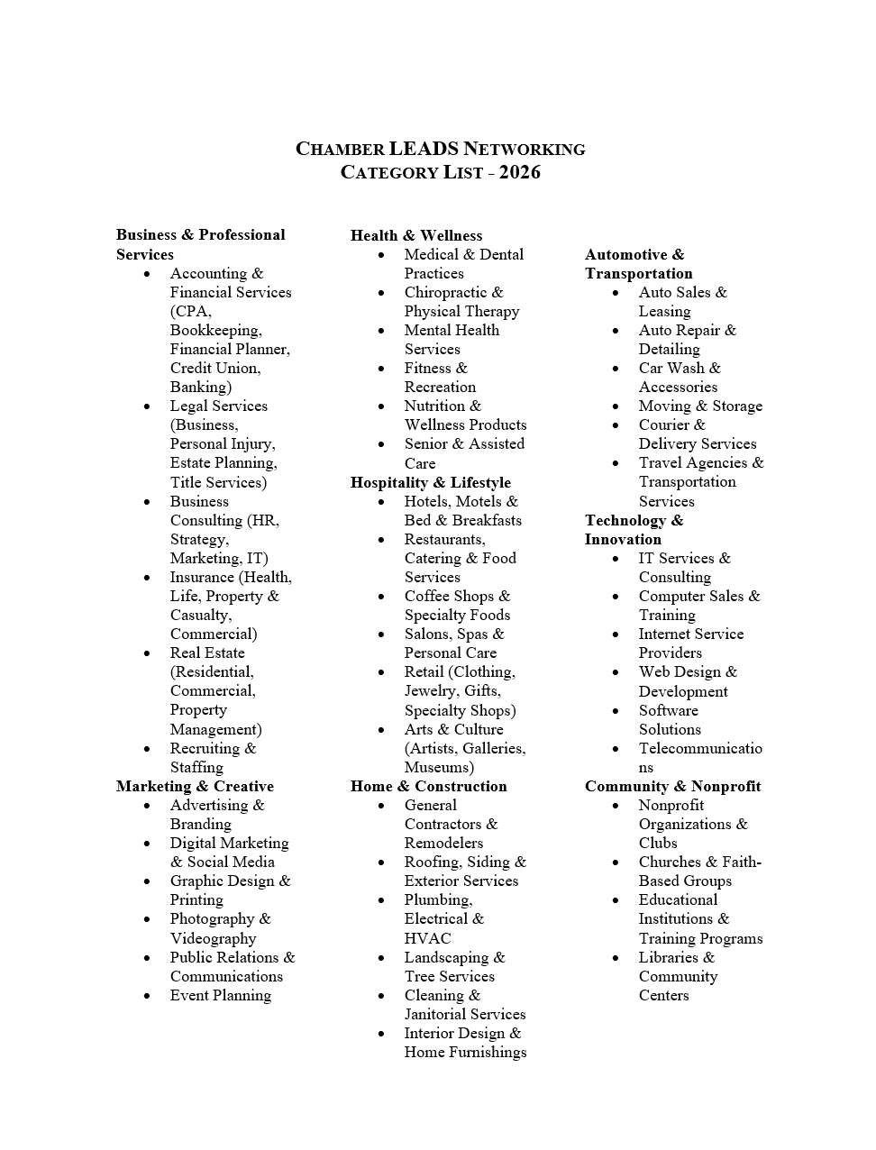

Chamber LEADS Networking

Tools, Motivation & Friendship

The people in your LEADS Networking group are volunteers on your business development team. To make the most of this opportunity, you must provide both the tools and the motivation.

Tools Are the Easy Part
- Share information about you and your business.
- Make sure members have your business cards, brochures, and contact details.
- Your 30-second commercial and 10-minute presentation are refreshers to keep your team up to date.

Motivation Is the Important Part
- Motivation is what inspires members to help you grow.
- Remember: it’s hard to motivate a team if you don’t show up for practice.
- Friends are highly motivated to help their friends — not out of obligation, but out of genuine connection.

Building Friendships
- Friendships take time and effort to cultivate.
- Make it a goal to build one new friendship each week.
- In 3 months, you’ll have 12 new friends who are educated and motivated to help you — and you’ll be motivated to help them.
- Weekly meetings become something you look forward to, not a chore.

The Power of Friendship in Networking
- It’s easier to invite friends to meet your business friends than to invite acquaintances.
- The more friendships you build in your group, the more fun you’ll have - and the more business you’ll generate.

Final Reminder
- Be patient. Strong relationships and quality referrals take time, consistency, and care.

Thank You for Being Part of LEADS

We are so glad you are a member of the Chamber LEADS Networking Group. Your commitment to building connections, sharing referrals, and supporting one another makes our community stronger.

Remember: the strength of LEADS is in the friendships and trust we build together. Your participation helps create opportunities not only for your own business, but for every member of the Chamber family.

Contact Information
Hanna Crouch | Director of Programs & Events | The Chamber of Grand Haven, Spring Lake, Ferrysburg

- Office: 616.842.4910
- Direct Line: 616.846.3165
- Email: hcrouch@grandhavenchamber.org

A Final Note
Thank you for being part of LEADS. Please don’t hesitate to reach out to me with questions, ideas, or needs. I’m here to support you and ensure your experience in LEADS is rewarding, productive, and fun.

Together, we’re building connections that last.

