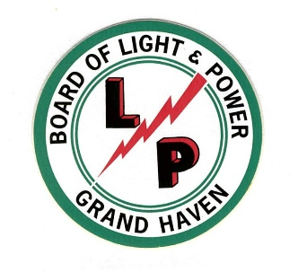

FOR IMMEDIATE RELEASE

ENTRIES NOW WELCOME FOR BLP HOLIDAY LIGHTING CONTEST
GRAND HAVEN, MICH., December 08, 2025 – Entries are open for the Grand Haven Board of Light and Power’s (BLP) Holiday Lighting Contest. The outdoor holiday lighting contest is broken into two different categories.
The first category is the ‘Griswold Award’ which is the most over the top lighting display. According to the BLP if it can be seen from space, then this is a good candidate display for the Griswold Award.
The second category is the ‘Classic Award’ for the most gorgeously designed display that captures the holiday spirit and looks like it jumped directly off the front of a Hallmark card.
To enter, BLP residential customers will need to submit their entries to customerservice@ghblp.org. The deadline for entering the contest is Monday, December 15th. Winners will be announced on December 19th. Each award recipient will receive $150 in Chamber Dune Dollars to spend locally.
Many residents put a lot of effort and pride into their holiday displays. Giving them a chance to showcase their love of the holiday season by making the community a brighter place is just another way in which BLP can facilitate bringing the community together.
The BLP serves over 15,000 residential, commercial, and industrial customers in the City of Grand Haven, City of Ferrysburg, Grand Haven, Spring Lake, and Robinson Townships.

###

