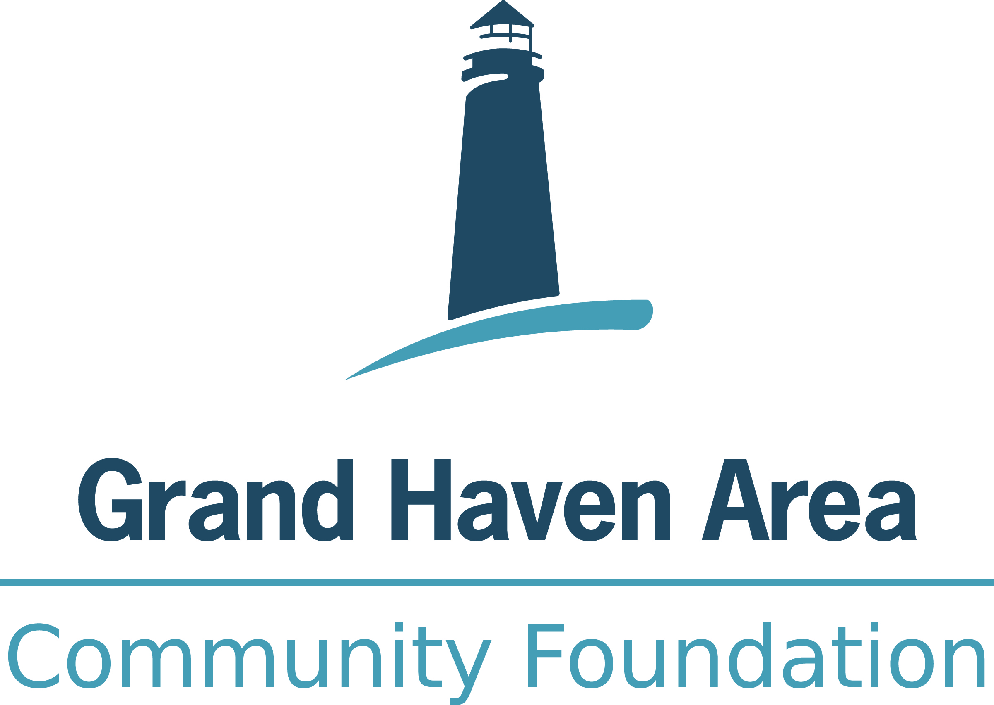

Job Title: Executive Assistant Date Created: December 2021
Job Type: Full-Time; Exempt Date Updated: April 2023
Reports to: President January 2025
Positions Supervised: Future determination

Purpose
Responsible for the efficient operation of administrative activities and clerical functions for the Foundation’s Leadership Team and Board of Trustees, including the two Affiliate Foundations. Inputs data, generates Foundation reports, proofreads, and edits high level documents, and maintains calendars. Assists with Foundation event planning including venue, invitations, guest list, and other details, as necessary. Relies on experience and judgement to plan and accomplish goals.
Specific Duties:
President and Leadership Team Support
- Organizing meetings, including scheduling, sending reminders, and organizing venues and catering and taking notes when necessary.
- Managing the Leadership Team’s calendar, as required, including making appointments and prioritizing the most sensitive matters.
- Compose/edit written correspondence for the Leadership Team.
- Maintains and manipulates the database for executive team including data entry, creating reports, exporting information, mailing lists and general upkeep, as needed.
- Assists with presentation materials, reports and surveys as assigned.
- Support human resource functions, as needed.

Board of Trustees Support
- Prepares and distributes information and materials for Board of Trustees and assigned committee meetings, including calendar invites, agendas, lists and packets. Coordinates assembling of the meeting materials with other staff, ensuring that materials are complete, accurate, timely and in accordance with professional presentation standards.
- Coordinates updating and preparing board and committee materials, including but not limited to: the annual board calendar, current roster and contact information, orientation materials, matrix, evaluations, materials for nominating process, etc.
- Takes professional board and committee meeting minutes.
- Assists with educational opportunities for the board.
- Manages and ensures completion of the Foundation, and its Affiliates, conflict of interest, confidentiality, and commitment forms.
- Maintains Board of Trustee SharePoint site for updated and relevant documents and access by trustees.
- Provides support for all Board events, taking the lead on many aspects including arranging venue, guest list, invitations etc., with assistance from the Administrative Specialist/Assistant.
- Coordinates the recognition of board member terms.

General Administrative Services
- Coordinates activities around the Foundation’s response to significant change in community leadership and friends. This includes, but isn’t limited to, coordinating Foundation representation at funerals, sympathy cards, memorials, flowers, thank card or gifts, congratulations, etc. and any updates to RE and distribution list(s).
- Coordinates responding to all sponsorships and event requests.
- Reconciles monthly credit card statements with receipts collected from card holder and processes quarterly leadership team member expense reports, if requested.

Other
- Has the potential to directly manage staff, including coaching, counseling and discipling employees.
- Serves as back-up to Administrative Specialist/Assistant for reception and hospitality of visitors and general office administrative support, as needed.
- Answers phone calls in a polite and professional manner
- Maintains comprehensive and accurate records

Other duties as assigned.

Knowledge, Skills and Abilities Required:

At a minimum, completion of an associate degree in office or business administration. Bachelor’s degree preferred. Coursework in business communications a plus.

Minimum of five years’ experience in an administrative function with the ability to work independently, prioritize, schedule and produce work in a timely manner.

Previous experience working with a Board or as an Executive Assistant desired, including responsibility for meeting minutes.

Familiarity with charitable foundation policies, procedures, and structure in order to conduct assigned programs and projects preferred.

Knowledge and high level of skill in utilizing Microsoft Office suite, Adobe Acrobat, CRM database (Foundant CSuite preferred), Asana project management a plus; ability to operate a wide variety of office equipment. Software testing may be required during interview process.

High level interpersonal skills necessary to work cooperatively with others and interact effectively and courteously with a diverse group of callers and visitors and be socially perceptive in contacts with influential individuals.

Analytical abilities necessary to proof and edit materials, calculate, and balance totals, maintain records and files, and organize and prioritize work assigned.

Exercises a high level of thoughtful and insightful judgment within areas of accountability.

Ability to handle confidential information in a professional manner.

Ability to prioritize and effectively manage time with many projects active at once.

Professional image, positive, upbeat, and enthusiastic with willingness to help in a team environment.

Ability and passion to contribute to a work environment in which collaboration, respect and honesty are valued. Excellent interpersonal skills required.

A strong sense of integrity and work ethic seasoned with humor and perspective.

A commitment to excellence and continuous learning and improvement - takes initiative to continue professional development.

Working knowledge of Northwest Ottawa County preferred.

Work Hours: Monday through Friday 8:30 a.m. to 5:00 p.m. with a one-hour lunch. (37.5 hours per week).

Pay Rate: Competitive and commensurate with education and experience. The Foundation has a comprehensive benefit package and a 403b Retirement plan.

